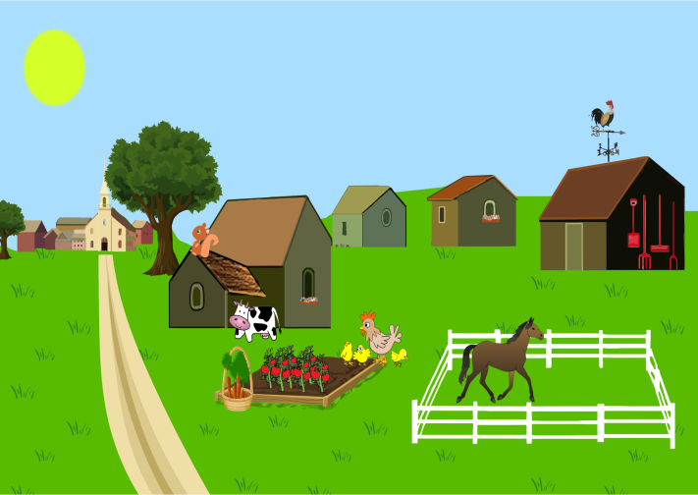
Year 2: Can We Build It?
We Are Learning To:
Build a sustainable farm for the future using everyday materials safely.
What I Am Looking For:
The identification of characteristics and properties of everyday materials that are used in the creation of your sustainable farm.
Your sustainable farm must:
- Be constructed from at least six different everyday materials.
- Have at least three components that show its sustainability.
- Show your ability to use the materials and tools safely.
Materials:
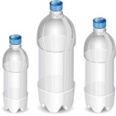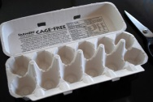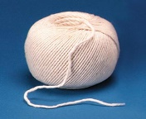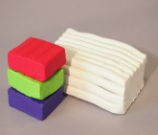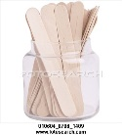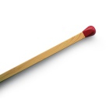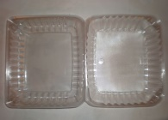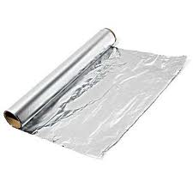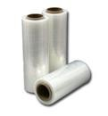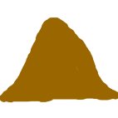

Tools:
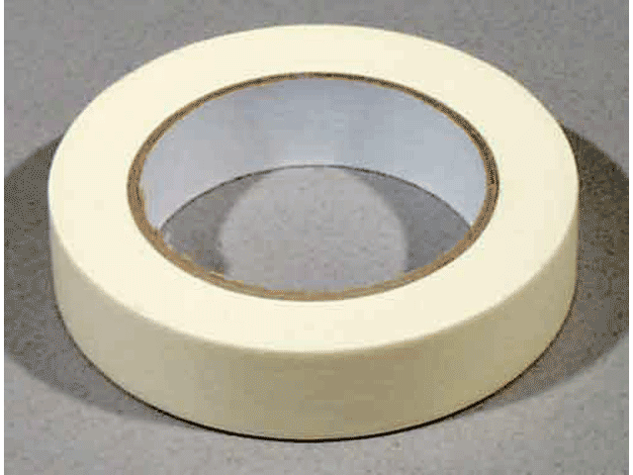
Contents:

Design Brief………………………………………. p. 1
Information for teachers………………….. p. 3
Unit Plan…………………………………………… p. 4 - 6
Differentiation and extension activities p. 7
Offline Resources……………………………… p. 8 - 10
Assessment rubric…………………………… p. 11

Information for Teachers
Year 2 students will learn that there is an essential future need for sustainable farming in Australia. Students will become active participants and create an ethical solution from using everyday recycled materials that can be used in the future for sustainable farming. Year 2 students will use design thinking and technologies to investigate, plan, produce and design an ethical, sustainable farm either individually or collaboratively (Australian Curriculum Assessment and Reporting Authority [ACARA], 2015).
By the end of the unit students should be able to;
- Identify and explain Australia’s future need for sustainable farming.
- Describe the properties and characteristics of everyday materials that are needed to create a sustainable farm.
- Plan and illustrate a sustainable farm applying knowledge of everyday materials properties.
- Create a sustainable farm by applying knowledge of everyday materials properties.
- Use tools and equipment appropriately.
Australian Curriculum v8.1 Technologies: Content Descriptors, General Capabilities and Cross-Curriculum Priorities

Content Descriptors

Design and Technologies Processes and Production Skills
Use materials, components, tools, equipment and techniques to safely make designed solutions (ACTDEP007)

Design and Technologies Knowledge and Understanding
Explore the characteristics and properties of materials and components that are used to produce designed solutions (ACTDEK004)

General Capabilities
Critical and Creative Thinking: Level 2
- Identify and clarify information and ideas
- Organise and process information
Creating with ICT: Level 2
- Generate solutions to challenges and learning area tasks
Cross-curriculum priorities
Futures: OI.8
- Designing action for sustainability requires an evaluation of past practices, the assessment of scientific and technological developments, and balanced judgements based on projected future economic, social and environmental impacts.

Can we build it?
Class Management: | - Students to work in Lesson 1 – 3 individually and collaboratively per requirements of activity  - Students to work in Lesson 4-5 either individually or collaboratively for the summative assessment.
Time Management: | - Five lessons  - Sixty minutes in length
Materials/Resources: | - Lesson 1 – 4 provided in the lesson overview below  - Lesson 5 Summative assessment materials provided on design brief cover page
Preparation: | - Print out all resources before lesson  - Examples and photo of teacher made example of a sustainable farm
Safety: | - Discuss correct use of materials, tools and equipment (ACTDEP007)
Lessons
Lesson 1: What is sustainable farming? | Objective: By the end of the lesson students should be able to identify and explain Australia’s future need for sustainable farming
Introduction (15 minutes) | - Introduce: WALT/WILF on Design brief  - Think, Pair, Share: Future, sustainable and farming on the Smartboard.  - Watch: Sustainability Agriculture at Fickle Creek Farm  - Stop and start to explain terminology to students  - Think, Pair, Share: develop answers on the Smartboard. | Resources:  - Smartboard  - Design brief p. 1  - YouTube video: Sustainability Agriculture at Fickle Creek Farm
Body (35 minutes) | - Watch: Farming for the Future  - Stop and start to explain terminology to students  - Discuss: The need for sustainable farming in Australia  - Activity: Why does Australia need sustainable Farms?  - Students can complete this activity individually or collaboratively in their sustainable farm group. | Resources:  - Smartboard  - YouTube video: Farming for the Future  - Why does Australia need sustainable Farms? worksheet p. 7
Conclusion (10 minutes) | - Discuss: groups answers and give oral feedback | Resources:  - Students completed Sustainable need activity
Lesson 2: Properties of Everyday Materials | Objective: By the end of the lesson students should be able to describe the properties and characteristics of everyday materials used to create a sustainable farm.
Introduction (15 minutes) | - Reintroduce: WALT/WILF on Design brief  - Brainstorm: Prior knowledge of future, sustainable, farming  - Think, Pair, Share: Everyday materials and their properties  - Activity: Show students a range of everyday materials (the same as on the design brief) and discuss their properties and what they could be used for on their farm. | Resources:  - Smartboard  - Design brief p. 9
Body (35 minutes) | - Activity: Which everyday materials will I use for my farm? Why?  - Students can complete this activity individually or collaboratively in their sustainable farm group. | Resources:  - Which everyday materials will I use for my farm? Why? p. 8
Conclusion (10 minutes) | - Discuss: Which everyday materials students will use on their farm and why | Resources  - Completed everyday material activity
Lesson 3: Plan of Sustainable Farm | Objective: By the end of the lesson students should have completed either individually or collaboratively their plan for their sustainable farm.
Introduction (10 minutes) | - Reintroduce: WALT/WILF on Design brief  - Brainstorm: Prior Knowledge of future, sustainable, farming and everyday materials.  - Explicit instructions: Introduce Design Brief and  explain sustainable farm plan | Resources:  - Smartboard  - Design brief p. 1  - Sustainable Farm Plan p. 9
Body (40 minutes) | - Activity: Sustainable Farm Plan  - Students can complete this activity individually or collaboratively in their sustainable farm group. | Resources:  - Sustainable Farm Plan p. 9
Conclusion (10 minutes) | - Discuss: Students explain their plans to the class | Resources:  - Students completed plan
Lesson 4: Build Sustainable Farm | Objective: By the end of the lesson students should have almost completed their building of their sustainable farm.
Introduction (10 minutes) | - Reintroduce: WALT/WILF on Design brief  - Brainstorm: Why we need to create a sustainable farm? What everyday materials can we use to create a sustainable farm?  - The purpose of the farm plan  - Explicit instructions: Explain Design Brief and how students need to use their plan to create a sustainable farm | Resources:  - Smartboard  - Design brief p. 1  - Farm plan p. 9
Body (40 minutes) | - Activity: Create sustainable farm  - Students can complete this activity individually or collaboratively in their sustainable farm group. | Resources:  - Completed plan  - Materials on design brief p. 1  - Tools from design brief p. 1
Conclusion (10 minutes) | - Discuss: What students have created so far. | Resources:
Lesson 5: Complete and explain Sustainable Farm | Objective: By the end of the lesson students should have completed their sustainable farm and be able to explain at least three sustainability components.
Introduction (5 minutes) | - Reintroduce: WALT/WILF on Design brief  - Discuss: Students creations and what sustainable features made out of everyday material they have made so far. | Resources:  - Smartboard  - Design Brief p. 1
Body (40 minutes) | - Activity: Finish off sustainable farm  - Students can complete this activity individually or collaboratively in their sustainable farm group. | Resources:  - Completed plan  - Materials on design brief p. 1  - Tools from design brief p. 1
Conclusion (15 minutes) | - Discuss: Students to explain to the class their sustainable farm and how they used the everyday materials and their properties to achieve this. | Resources:  - Completed sustainable farm

Differentiation
- Use of a range of resources for visual, spatial, logical-mathematical, kinaesthetic, interpersonal and intrapersonal learners.
- Tailored activities depending on ability level
- Explicit clear instructions
- Scaffolding: students’ knowledge and understanding through a series of learning experience to create a sustainable farm.
- Blooms Taxonomy questioning at the end of each lesson to gain students’ knowledge and understanding. Use the words tell, describe, explain, discuss, outline, show, construct, identify, create and justify as question starters.
- Individual or Collaboration depending on student preference
- Constructivism

Extension activities
- Read: What we have on Farms by Chloe Deacon – Stock
- Watch: Australian Agriculture – The Greatest Store Never Told
- Watch: Investigating Materials
- Activity: Create/Draw a mind map of all the words that relate to future, sustainable and farm
- Activity: Label and describe the components of sustainability on your farm
- Activity: Write a narrative story about your farm

Why does Australia NEED sustainable farming?
Draw and/or write your answers in the boxes below
Group Name/Name:_________________________________________

Reason 1  Australia needs sustainable farming  because __________________________  ________________________________  ________________________________  ________________________________  ________________________________ | Reason 2  ________________________________  ________________________________  ________________________________  ________________________________  ________________________________  _________________________________ | Reason 3  ________________________________  ________________________________  ________________________________  ________________________________  ________________________________  _________________________________
Group Name/Name:_________________________________________
Which everyday materials will I use to build my farm?
Draw and/or write your answers in the boxes below
Group Name/Name:_________________________________________
Type of Material:  Why:________________________________  ____________________________________  ____________________________________ | Type of Material:  Why:________________________________  ____________________________________  ____________________________________ | Type of Material:  Why:________________________________  ____________________________________  ____________________________________
Type of Material:  Why:________________________________  ____________________________________  ____________________________________ | Type of Material:  Why:________________________________  ____________________________________  ____________________________________ | Type of Material:  Why:________________________________  ____________________________________  ____________________________________

Draw and label your sustainable farm
Don’t forget to include at least SIX everyday materials and at least THREE sustainability components.

I/We think that this is the best sustainable farm because ________________________________________________________________
______________________________________________________________________________________________________________
______________________________________________________________________________________________________________
______________________________________________________________________________________________________________
Name:________________________________________
Can We Build It? Rubric
Year 2 Technologies
 | Excellent | Good | Satisfactory | Developing | Limited
Identify reasons and explain Australia’s future need for sustainable farming. | Identifies 3 or more reasons with extensive explanation for all 3 reasons for sustainable farming in Australia. | Identifies 3 reasons with an extensive explanation for all 3 reasons for sustainable farming in Australia. | Identifies 3 reasons with a basic explanation of the 3 reasons for the need for sustainable farming in Australia. | Identifies at least 1 -2 reasons with simple explanation for the need for sustainable farming in Australia. | Identifies 1 reason with no explanation.
Describe the properties and characteristics of everyday materials used to create the sustainable farm. | Constructed from eight or more different everyday materials and able to describe all properties and characteristics. | Constructed from seven different everyday materials and able to describe most properties and characteristics. | Constructed from six different everyday materials and able to describe some properties and characteristics. | Constructed from at least three different everyday materials and able to describe some properties and characteristics. | Limited use of everyday materials and unable to describe properties and characteristics of materials used.
Plan and illustrate a sustainable farm applying knowledge of everyday materials properties. | Plan is complete with eight or more everyday materials used to three or more sustainability components. | Plan is complete seven everyday materials used to show three or more sustainability components. | Plan is complete with at least six everyday materials used to show three sustainability components. | Plan is somewhat complete and shows at least three different everyday materials and able to show at least one sustainability components. | Plan is incomplete with limited use of everyday materials and no showing of sustainability.
Create a sustainable farm by applying knowledge of everyday materials properties. | Farm is constructed from eight or more different everyday materials. | Farm is constructed from seven different everyday materials. | Farm is constructed from six different everyday materials. | Farm is constructed from at least three different everyday materials. | Farm is incomplete and constructed from limited materials.
Appropriate use of tools and equipment. | Able to construct a farm from everyday materials and use all tools and equipment appropriately. | Able to construct a farm from everyday materials and most tools and equipment appropriately. | Able to construct a farm from everyday materials and some tools and equipment appropriately | Farm is somewhat constructed and able to use a few tools and equipment appropriately. | Unable to construct a farm from everyday materials and inappropriate use of tools and equipment.
Feedback:

